Unit 3 Enduring Understanding:

*Scientific and social progress provide people a greater level of control over their surroundings and their lives, but can also lead to problems.*.

*Essential Question:*

1. *What fields of science were most revolutionized in the 17th Century? 2. How did the concept of natural law eventually impact the Age of Enlightenment?*

**Science before 17th Century…**

* **List Leonardo da Vinci’s many talents:**
* **Montaigne (1533-1592)**
  + 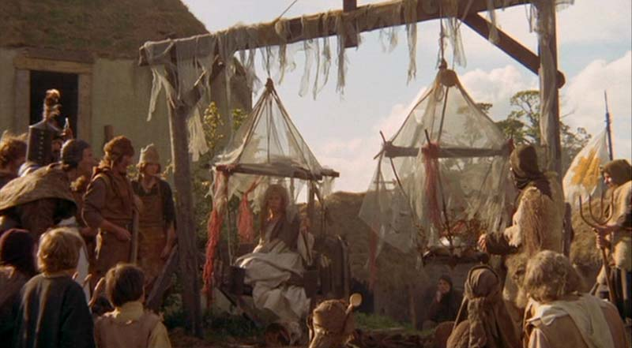**Describe Skepticism:**

**Witchcraft Panic: At its height (1450-1650)**

*Why were women accused more of being witches?*

|  |  |  |
| --- | --- | --- |
| **Bacon ( )** | **Descartes ( )** |  |
| BOTH:   * Publish between * Address problem of knowledge * Hold that _______________ method was backwards * Truth is the PRODUCT OF _______________________ | | **Similarities** |
| * Bacon planned a multi-volume text (**Instauratio Magna**), but only two parts were ever completed. * Part 1: 1620 – **Novum Organum**:   *INDUCTIVE METHOD -*  Define Formalized “Empiricism”   * Part 2: 1623 – **The Advancement of Learning** * **The New Atlantis**: Describes a scientific utopia * Knowledge could be made practical: * *Weaknesses* of Bacon’s thoughts: | * Invents Coordinate Geometry   + Anything can be plotted   + 1637: _______________________   + Principle of Systemic Doubt   + Can Not Doubt his own existence because he thinks:   + Cartesian Dualism   + God Creates _____ realities   + Thinking Substance and extended substance (not in mind) * __________________ provides more avenues than ___________________ | **Differences** |

Describe the involvement women had in science: